JAIR ANTONIO COSTA JUNIOR

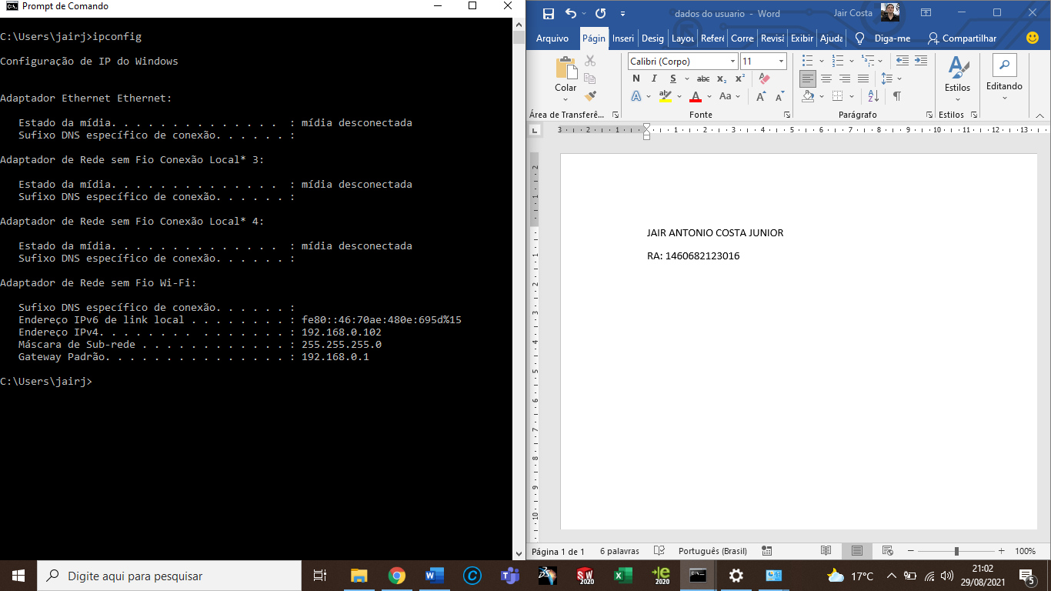RA: 1460682123016

